ReactJS Hands-On Lab
Student Management Portal – Score Calculator App

Objective
In this lab I created a React app for a Student Management Portal called scorecalculatorapp. The app has a function component named CalculateScore that takes in a student's Name, School, Total and Goal, calculates the average score, and displays it on the page.

Step 1: Creating the React app
I opened the command prompt inside my lab folder and ran the create-react-app command to scaffold a new project named scorecalculatorapp:
npx create-react-app scorecalculatorapp
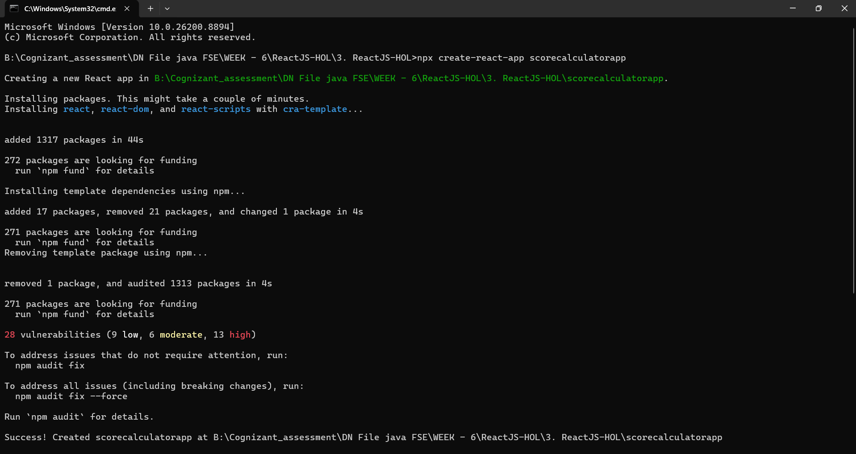
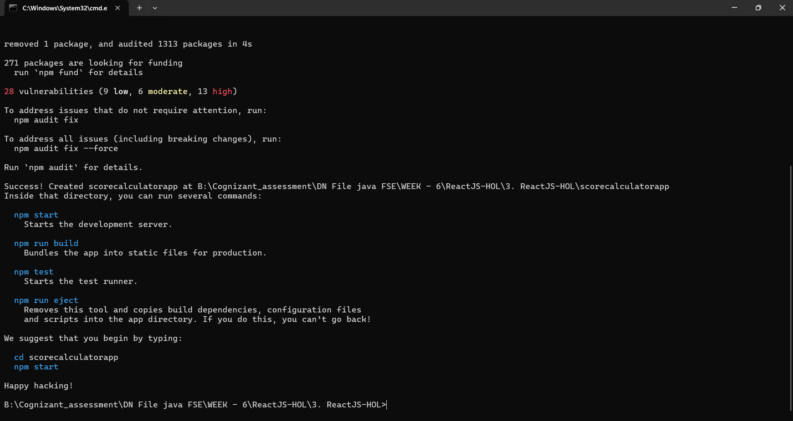
The packages installed successfully and the terminal confirmed that the project was created at the correct path, along with the usual set of npm commands I can use inside it.

Step 2: Creating the CalculateScore component
Inside the src folder, I created a new folder called Components and added a file named CalculateScore.js. In this file I wrote a function component that accepts Name, School, total and goal as props, calculates the percentage score using a small helper function, and renders the student's details:
import '../Stylesheets/mystyle.css'
const percentToDecimal = (decimal) => {
return (decimal.toFixed(2) + '%')
}
const calcScore = (total, goal) => {
return percentToDecimal(total/goal)
}
export const CalculateScore = ({Name, School, total, goal}) => (
<div className="formatstyle">
<h1><font color="Brown">Student Details:</font></h1>
<div className="Name">
<b><span>Name: </span></b>
<span>{Name}</span>
</div>
<div className="School">
<b><span>School: </span></b>
<span>{School}</span>
</div>
<div className="Total">
<b><span>Total:</span></b>
<span>{total}</span>
<span>Marks</span>
</div>
<div className="Score">
<b>Score:</b>
<span>
{calcScore(total, goal)}
</span>
</div>
</div>
)

Step 3: Styling the component
Next, I added a Stylesheets folder inside src and created mystyle.css to give the different fields their own colours and to center-align the whole card:
.Name
{
font-weight:300;
color:blue;
}
.School
{
color:crimson;
}
.Total
{
color:darkmagenta;
}
.formatstyle
{
text-align:center;
font-size:large;
}
.Score
{
color:forestgreen;
}

Step 4: Wiring it up in App.js
I then edited App.js to import the CalculateScore component and render it with some sample student data (Name: Steeve, School: DNV Public School, total marks: 284, goal: 3):
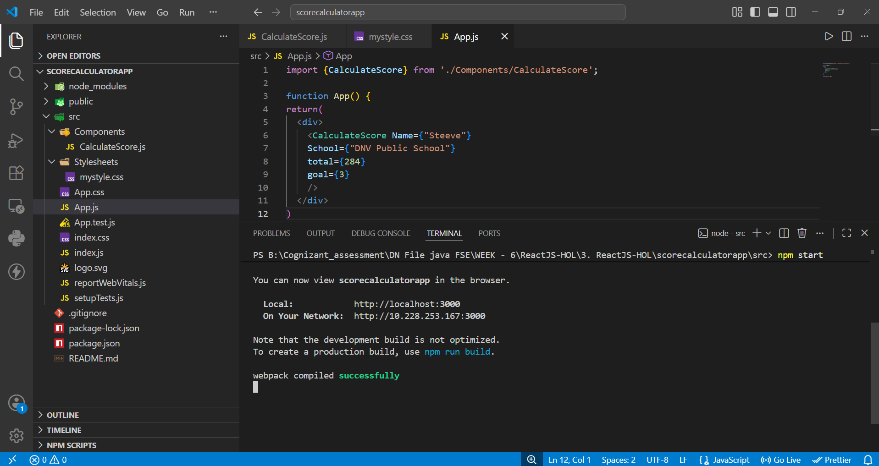
The screenshot above shows the final App.js file open in VS Code, along with the terminal output on the right after running npm start — the app compiled successfully with no errors.

Step 5: Running the app
From inside the scorecalculatorapp folder, I ran npm start, which launched the development server and automatically opened the app at localhost:3000 in the browser:
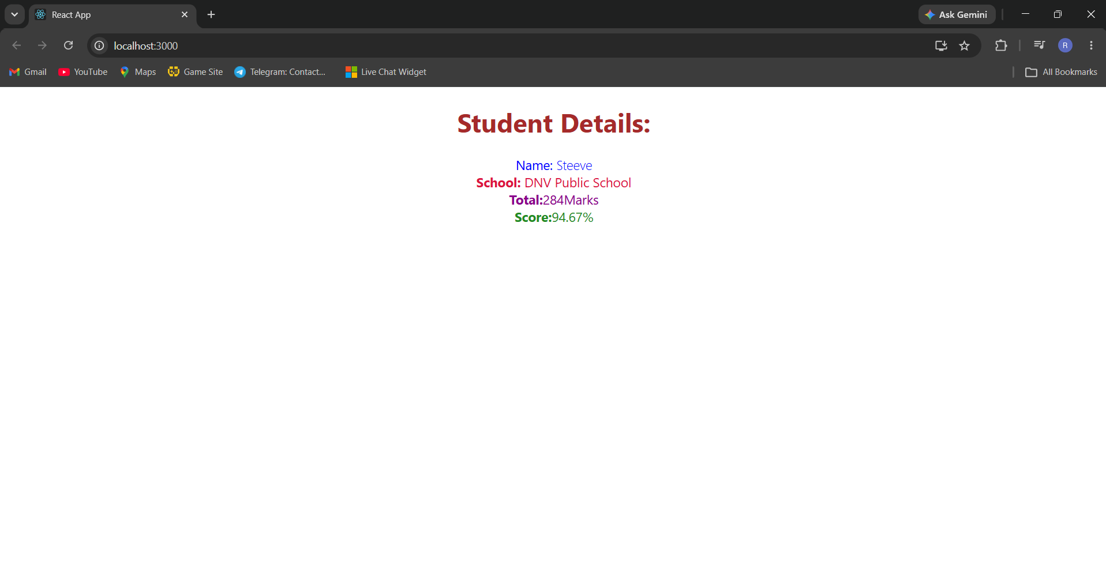
The page displays the Student Details heading along with the Name, School, Total and the calculated Score (94.67%), each styled with the colours defined in mystyle.css, confirming that the component is working correctly.

Conclusion
This lab helped me understand how to build and use a function component in React, pass data into it using props, apply external CSS styles to a component, and render it inside App.js. The final output correctly calculates and displays a student's score based on the total marks and goal provided.

